The Impact of Executive Coaching on Toxic Leaders

Nicole Jencen

National University

Abstract

This capstone project seeks to explore the impact of executive coaching on toxic leaders. This paper reviews published articles that seek to understand toxic leadership traits and behaviors, how it impacts subordinates, the organization in which they work, and if executive coaching can make a positive impact. This topic has been an area of study among scholars and has recently been deemed as an epidemic in the workplace. Toxic leadership has been classified as difficult to remedy, but there are journals that describe leaders transforming to better themselves when executive coaching is implemented. This study will focus on the significance of coaching the toxic leader to reverse the dysfunctional behaviors and to strengthen their abilities to lead with positive influence. The purpose of this research is to identify those who display toxic leadership traits are able to change through implementation of executive coaching. This study will examine literature that will seek to explore the primary research question through utilization of mixed method research: qualitative and quantitative methods. The research methodology of the study will use interview methods, personality tests, and non-experimental design to explore the relationship between coach and leader that will use statistical analysis of cause and effect of coaching that will be observational only in terms of data collection.

*Keywords:* executivecoaching, toxic leadership, effects of toxic leadership on subordinates, dysfunctional leadership

**Table of Contents**

Chapter One: Introduction to the Study 4

Statement of the Problem 6

Purpose of the Study 7

Primary Research Questions 7

Hypotheses and Intended Outcomes 8

Chapter Two: Literature Review 9

Toxic Leadership Traits 9

The Effects of Toxic Leadership on Subordinates 12

Assessing Traits of the Toxic Leader 13

Coaching Leaders Who Display Toxic Traits 16

Chapter Three: Methodology & Research Design 19

Overview of Dippenaar and Schaap Research 19

Dippenaar and Schaap Method Results. 22

Setting and Participants 22

Instrumentation of the Research Design 23

Procedure of the Study 24

Data Processing and Analysis 25

Personality Tests Scoring 26

Ethical Considerations 26

Limitations to the Study 26

Research Validity 27

References 28

Appendix A 33

Appendix B 34

# Chapter One: Introduction to the Study

Our human culture seeks to find special qualities within another that possess the capability to uplift followers, inspire personal growth, endure courage, and transform society. These descriptions define the word, “leader” which has a positive connotation. The word “toxic” has a negative connotation in which the synonyms are referred to as poisonous, dangerous, harmful, unsafe, and environmentally unfriendly (Pelletier, 2012). Research is now exploring and discussing the epidemiology of toxicity in a corporate workplace environment. This study seeks to identify the effects that a toxic leader can have on a follower or subordinate.

Corporate leaders who have shown negative behaviors toward their followers have been demonstrated throughout world history. The significance of this study will identify the traits and behaviors of toxicity that infiltrate small and large corporations. These characteristics, traits or behaviors can be identified by professionals such as psychologists, doctors, and even professional executive coaches. The condition of a toxic leader may be classified as a disorder that may be able to be managed. This study will focus on the significance of coaching the toxic leader to reverse the dysfunctional behaviors that may in turn strengthen their abilities to lead with a positive influence.

The literature reviewed throughout this study examines the question: are executive coaches capable of positively influencing behavioral intervention in those leaders who display toxic behaviors? This study provides empirical support in which executive coaching can positively impact leaders that display behaviors and traits that are causing harm to others within a corporate setting. Much of the literature states there have been positive results by working with an executive coach, although, the underlying problem identified is often the leader in power reverts back to old behaviors.

Many researchers mention throughout their studies that toxic behaviors can be difficult to change due to the nature of their mental state. Goldman suggests, “Coaches and consultants will testify to the fact that corporate toxicity rarely has a single cause, leader, or culprit” (2009, p. 18). The literature is suggesting that even though a leader has been identified by others as toxic, it may be difficult for a coach to pin-point the root cause of their destructiveness, and the derailment of their business. Mehta states, “The term toxic leadership was coined by Whicker (1996), and is linked with a number of dysfunctional leadership behaviors” (2013). Mehta describes toxic leaders to be “maladjusted, malcontent, malevolent and even malicious. They succeed by tearing others down” (2013).

Research suggests a toxic leader can impose psychological damage that can be profoundly destructive to the well-being of a subordinate (Mehta & Maheshwari, 2013, Pelletier, 2012, Pelletier, 2010). Additionally, the research labels toxic leaders’ behaviors and traits are similar to those diagnosed with narcissism, Munchhausen syndrome, personality disorders, and sociopaths (Burke, 2017; Bartlett, and Bartlett, 2011; Burns, 2017). The research states even well-seasoned coaches are unable to handle the severity of these diagnoses (Goldman, 2009). To understand the complexity of what coaching is capable of, Dippenaar suggests, “effective coaches must have knowledge and experience of the psychology of stimulating self-awareness and personal responsibility that foster ongoing self-directed learning and personal growth” (2017, p. 4).

Even though there are many existing articles that focus on the positive effects of leadership, there are more recent studies available that discuss the negative aspects of leadership (Mehta, 2014). This study will discuss the negative effects, traits and behaviors of leaders in corporate settings. These negative effects can include harassment, ridicule, mental torture, employee stress, company morale, and more (Mehta, 2014).

## Statement of the Problem

Dysfunctional corporations often breed leaders that display traits and behaviors that are toxic to their environment. A dysfunctional corporation can be described as, “The quality of human relationship is swept aside. Emotional intelligence becomes a footnote, an afterthought. Greed and power plays emerge” (Goldman, 2014, p. 20). Often corporate leaders such as Chief Operating Officers (COO), Chief Financial Officers (CFO), corporate owners, upper management, and lower management can lead from a place of self-servingness where they put their own needs before the needs of their employees or company (Dandira, 2012; Goldman, 2006; Hubbard, 2018).

Executive coaches are trained to influence, inspire, and transform those who hold positions of power (Dippenaar, 2017). Coaching can begin the transformation process by formulating goals that will impact the betterment for their client’s future (Kets De Vries, 2014). Even though coaches are able to work with leaders that display toxic behaviors and identified traits of toxicity, can they transform their behavior permanently? Various research suggests that it is unlikely due to the nature of their underlying diagnoses which can be characterized as narcistic, sociopathic, and emotionally inept (Goldman, 2014; Kets De Vries, 2014). These behaviors can leave an everlasting devastation within their business culture, colleagues, employees, and followers (Pelletier, 2010; Romm, 2007). Through non-experimental investigation, and empirical research, the purpose of this study is to determine how to identify a toxic leader by understanding their displayed traits and behaviors, to assess the effect on those who work with them, and to examine if executive coaches are able to promote change.

## Purpose of the Study

The purpose of this research is to identify those who display toxic leadership traits can change their behaviors through executive coaching. The goal of this study is to determine if the toxic leader can change permanently with guidance of coaching. There are four objectives throughout the literature review: examine toxic behaviors and traits, toxic effects on the work place environment, the repercussions of those who interfaced with toxic leaders, and explore the reversal of toxic behaviors by utilizing executive coaching.

The methodology of this paper will expand on Dippenaar and Schaap research design that indicates the impact of coaching on leader’s emotional and social intelligence by implementing a mixed method approach using qualitative and quantitative methods (Dippenaar, 2017). This study furthers Dippenaar’s research by interviewing the leaders used in Dippenaar’s study approximately one year after their coaching session with Dippenaar’s subjects. Through utilizing a non-experimental analysis, the data will seek to determine if the subjects were capable of change, or to what degree of change occurred.

## Primary Research Questions

The primary research questions this study seeks to examine are: What strategies do executive coaches use to promote change in clients who are reported to display toxic leadership traits and behaviors?

1) What traits and behaviors do corporate leaders display in order to be labeled as “toxic”?

2) What are the effects of toxic leadership on subordinates?

3) How can an executive coach assess the traits of the toxic leader?

4) Is it possible to coach a toxic leader?

## Hypotheses and Intended Outcomes

This study will examine literature that will seek to answer the primary research question through utilization of mixed method research: qualitative and quantitative methods. The research methodology of the study will use interview methods, personality tests, and non-experimental design to explore the relationship between coach and leader that will use statistical analysis of cause and effect of coaching that will be observational only in terms of data collection. The hypothesis includes the data will determine that coaching has a positive effect on those leaders who display toxicity, but the changes will not be permanent, and they will revert back to old behaviors after their consulting is over.

# Chapter Two: Literature Review

The introduction to this literature review will explore over twenty-five peer-reviewed articles on the topic of toxic leadership. Throughout this paper, we will define what a toxic leader is and why toxic leadership is a problem in present-day society. The literature presented explores how executive coaches work with clients who display traits related to toxic leadership. The literature collected will propose four concepts that will be discussed throughout this review: 1) toxic leadership traits and behaviors, 2) the effects of toxic leadership on subordinates, 3) assessing the traits of the toxic leader, 4) coaching a toxic leader.

The evaluation of this literature review explores how coaches can support leaders who display toxic traits that may be able to develop an ability to lead and manage in a healthier manner when utilizing leadership coaching. The focus of the research is to recognize toxic leadership traits, understand the effects of toxic leadership on subordinates, and review how coaches have supported those who display toxic leadership traits.

## Toxic Leadership Traits

According to literature, toxic leader traits may be difficult to recognize. Mehta et al. research states, “Toxic leaders offer grand illusions to followers which are unattainable visions and grandiose dreams of an unrealistic future” (2013, p.4). This is the beginning of coercing the subordinate, Mehta (2013) continues, “These grand illusions make the follower totally dependent on the leader with the hope of accomplishment of these illusions and comply with the leader and become an easy prey to his or her enormity” (p. 4). The significance of what Mehta is stating offers insight into a characteristic of a toxic leader; coercive.

Another characteristic Lipman-Blumen et al. defines is, “a process in which leaders, by dint of their destructive behavior and/or dysfunctional personality characteristics, inflict serious and enduring harm on their followers, their organizations, and non-followers, alike” (2017, p. 4). According to Burke (2017), defines toxic leadership behavior as, “exploitative, abusive, destructive, and psychologically-and perhaps legalistically-corrupt and perhaps poisonous’” (p. 11). Burns conducted a literature review of harmful leadership styles. His research describes a plethora of harmful types of leadership (2017), “the egotistic leader, the incompetent leader, the ignorant leader, and leaders that are reckless, cruel, or even evil” (p. 1). Burns (2017) research focused on the commonalities between all harmful leadership types, the negative consequences of their actions such as bullying, and assesses how the harmful leadership might be mitigated (p. 2).

A study conducted by Cote explores toxic leader traits which may be benign or toxic to the self, organization, subordinates, and colleagues. Cote’s research discusses the concept of “derailment” which refers to leaders who fall off course from leadership ethical obligations. Cote’s research conducted psychological tests on those leaders that derailed which included mental ability, personality traits, motivations, and vocational interests (2018). The findings identified toxic leader’s focused more on self-interests over the importance of their teams, relationships, and company goals. Often traits of a toxic leader exhibited the use of Laissez-Faire leadership style that often leads to self-promotion, narcissism, lack of empathy for subordinates, and lack of individual growth.

According to Burns (2017), the commonality of toxic behaviors ranges from “negative intent, to ineffective leaders notable not for malevolence but for a dearth of positive results” (p. 8). The work by Hubbard proclaims in her research toxic leadership is on the rise in the workplace (2018). Hubbard states, “The three significant antecedents of a toxic leader are abusive leader supervision, unfair justice, and an unethical work environment” (2018, p. 12). There are many words to describe toxic leadership traits such as destructive, or dysfunctional but they all lead to the same result known as the “dark” side of leadership. According to Thoroughgood (2016), “The term ‘destructive leadership’ has been used as an overarching expression to describe various ‘bad’ leader behaviors believed to be associated with harmful consequences for followers and organizations” (p. 1).

The behaviors of a dysfunctional leader can be defined simply as abusive according to Pelletier et al (2010), “Researchers have proposed descriptions of harmful leadership that fall within the domains of abusive” (p. 2). Abusive and tyrannical leadership, according to Pelletier, can be described as displaying hostile behaviors (2010). Her literature states, “Abusive leaders are characterized by their injurious actions that include public ridicule, angry tantrums, inconsiderate actions (i.e. rudeness), favoritism, non-contingent punishment, and coercion” (2010, p. 2).

A toxic leader may display behavioral traits that are described to blame their followers for mistakes, discourage interaction with other subordinates, and deter initiates (2010). Destructive characteristics according to Pelletier’s research can be described as, “undermining, demeaning, marginalizing, intimidating, demoralizing, and disenfranchising followers, to ‘incapacitating, imprisoning, terrorizing, [and] torturizing’” (2010, p. 4). According to Vredenburgh, “A powerholder’s exercise of power can increase or decrease other’s feelings of dignity and self-respect” he goes on to say, “The exercise of power can contribute to or diminish subordinates’ job performance and acquisition of deserved rewards” (1998, p. 1339). Powerholder is another term for “leader” and throughout Vredenburgh’s research, he describes the behaviors of abuse upon subordinates. His research entailed 505 MBA students at a US-based school; 369 students were employed with an average of 2 years of work experience. The students provided examples of leaders who abused their power and were asked to respond to the following question, “What did the boss do that made it abusive?” (1998, p. 1339). Their findings included a leader who withheld information that would improve upon their work performance and when the subordinate was deserving of a reward but did not receive one (1998).

## The Effects of Toxic Leadership on Subordinates

Research acknowledges there will be adverse effects on subordinates and followers who experience abuse from a toxic leader. Pelletier’s (2011) research indicates that subordinates often have counterproductive behaviors to even the score with their superior. Subordinates tend to attribute negative reciprocity toward their company and leader during and after the abuse (2011). According to Pelletier (2011), “At the individual level, studies have shown abusive leadership to be related positively to turnover intentions and psychological distress, and related negatively to affective and continuance commitment, job and life satisfaction” (p. 378). She continues to say, “Further, employees subjected to leaders who attack their self-esteem tend to feel low self-worth and a diminished sense of self-efficacy that could lead to deteriorations in performance and morale” (p. 378).

Dandira et al. (2012) research relates toxic leadership to an “organizational cancer”. He suggests to understand what leadership is and is not is important, “Planning, organizing and controlling are essential management skills. Persuasiveness is not leadership. It is important to understand what leadership is all about so that we can really have an appreciation of how it affects the organization as a cancer” (p. 1). Dandira suggests bad leadership can lead to high turnover of employees due to low morale and this can be cancerous to organizations (2012). According to Dandira, “People do not quit companies, they quit because of managers or leaders” (p. 3).

A study conducted by Pelletier (2010) interviewed an employee who stated, “My boss wanted me to continue to allow others to take credit for my ideas and work and not say anything, which allowed those individuals to get promotions over me” (p. 381). Another example within her research is a woman who was being discriminated against, “My boss put her arm around me stating that I was her little Jew girl. I was the only person whose behaviors were recorded” (Pelletier, 2010, p. 381). The other subjects in the study reported their superiors’ behaviors included throwing tantrums, yelling, or used physical force to gain compliance (2010).

Another study by Vreja (2016) discussed the effects of toxic leadership on employees. The study suggested that corporations are having difficulties in defining, and detecting toxic leaders (2010). According to Vreja, some organizations lack experience and abilities to counteract the effects of toxic leadership (2010, p. 1). Corporations are often forced to pay the hidden costs inflicted by the behavior of the toxic leader. The costs can include reduced productivity due to the increase of absenteeism, weak performance of employees due to lack of commitment and dissatisfaction at work, decreased revenues due to the reputational damages of the organization, and legal costs (2010).

## Assessing Traits of the Toxic Leader

Burke (2017) presents in his research, “Toxic leadership behaviors can be changed, though not easy. Assessment tools, 360 degree feedback, coaching and mentoring, and punishing toxic leaders can be helpful” (p. 1). Throughout this paper, we have discussed harmful leadership traits, and the effects on subordinates, now we will assess the traits of the toxic leader. Through Burke’s research the possibility of rehabilitation comes to fruition. Burke states, “Toxic leaders are found in all countries, cultures, sectors and organizational levels” (p. 11). According to Burke (2017), some toxic leaders may have undiagnosed mental illness, “Psychopathy has been defined as a cluster of personality traits and behaviors that include ‘superficial charm, dishonesty, ego-centrality, manipulativeness, risk-taking and a lack of empathy and guilt masked as apparent normalcy’” (p. 12).

Goldman’s (2006) research through Diagnostic and Statistical Manual of Mental Disorders assess interpersonal and organizational dysfunction. His case study samples two personality disorders: narcissistic personality disorder and antisocial personality disorder. According to Goldman et al. (2006), “Personality disorders and their organizational contexts point to the presence of pathologies in the workplace generally falling outside of the expertise area of leadership scholar and management consultants” (p. 2). Goldman’s study evaluated toxic leaders who were diagnosed with NPD (Narcissistic Personality Disorder), “Yes, narcissism is the initial driving force behind many leaders” (p. 9). Antisocial personality disorders may also be a likely trait when dealing with a toxic leader. An example of their behavior according to the research, “If he saw you ‘screwing up’ at your station, he was very likely to walk right over, grab your arms and manhandle you into the ‘correct’ behavior at the factory line” (2006, p. 12).

On the contrary, research states narcissistic leadership traits are necessary when running an organization. According to Swid et al. (2018), “While Narcissistic leadership has always had a bad reputation, however many of today’s largest companies have CEO’s and leaders who can be characterized as narcissistic leaders” (p. 1). The examples used in Swid’s research recognized powerful modern day leaders who may have been diagnosed with NPD: Henry Ford, John D. Rockefeller, Walter Disney, or Steve Jobs (2018).

Swid states there are different types of narcissism: overt and covert leadership styles. According to Swid, “a person who was characterized, as a covert narcissist is introvert, vulnerable and even hypersensitive. Covert narcissistic leaders often share character elements like entitlement or explosiveness; these characteristics are often associated with aggression” (p. 32). Research also suggests that covert narcissists can suffer from social anxiety (2018). According to Swid, “Some researchers have distinguished that overt narcissists can both see themselves and be perceived as controlling, assertive and high risk-taking as well. More importantly, overt narcissism is strongly associated with self-serving dominance and desire for success and achievement” (p. 32).

The consensus of many articles deems toxic leaders to have certain personality flaws such as narcissism. Researchers have also found a phenomenon in organizations called leadership derailment this is when leaders fail at being effective (Cote, 2018). According to Cote’s et al. research, “The leader’s self-interests are more important than working in developing teams, relationships, and culture to achieve organizational goals” (p. 3). Derailed leaders “follow the theory of Laissez-Faire leadership style follows a “hands-off” approach resulting in a lack of decision-making, relinquishes responsibility, lack of feedback to employees” (Cote, p. 3).

Job stress that both the leader and the subordinate endure can cause behavioral issues to worsen. According to Cote’s research, “80% of workers jobs are stressful, and 75% of workers bosses make it a stressful work environment” (p. 4). Another statistic mentioned in Cote’s study stated, “73% of workers stated they ‘would not want their boss’s job!’” (p. 4). According to another study, Syaifuddin et al, states, “Stress is a reaction of the body to the environment to protect yourself, it is a natural defense mechanism that makes one alive” the study continues, “Lower levels of stress make a person think and try to answer the challenges of life, and even make life colorful. But high and prolonged stress will cause interference on the health and body and soul” (2016, p. 44). Luthan (2007) states, “stress is a response to the adjustment is affected by individual differences and psychological processes as a consequence of environmental actions, situation that cause too much psychological and physical demands”. According to Syaifuddin, companies will also suffer from work stress due to a decline in morale, employee frustration, absenteeism, decreased productivity and anxiety. Colt proclaimed a bold statement, “Psychologists believe unethical leaders are the result of negative (destructive) personality traits, including narcissism, Machiavellianism, and psychopathy” (p. 2).

## Coaching Leaders Who Display Toxic Traits

The term “coaching” can be defined as, “a helping relationship formed between a client who has leadership, managerial, or supervisory authority and responsibility in an organization” (Dippenaar, 2017, p. 4). A coach or executive coach will use a range of techniques to assess their clients, set goals to improve upon, and ensure the well-being and effectiveness of the organization. According to the research of Dippenaar, coaching a leader who displays toxic traits can be difficult. Coaching a leader that displays toxic traits should first evaluate their emotional intelligence (EI) according to Dippenaar. The main components of EI are intra/inter-personal skills such as self -regard, emotional self-awareness, independence, empathy, and self-actualization. Other EI components are: stress management, adaptability, and overall mood evaluation.

Dippenaar used a mixed approach using qualitative and quantitative methods within his study. He investigated the impact of coaching on relevant supervisors. Furthermore, the study aimed to empirically investigate the effectiveness that coaching has in developing leaders who display emotional unintelligence (Dippenaar, 2017, p. 2). He collected data using human samples, data collection, and analysis techniques. The following calculations were used to show the effects of change on leaders who are utilizing coaching methods: Total EQ (r=0.56: large effect), Intrapersonal (r= 0.37: medium effect), Interpersonal (r=0.37: medium effect) and Stress management (r=0.34: medium effect) (Dippenaar, 2017, p. 9). The quantitative findings showed that coaching statistically made a significant impact on the participants in relation to their emotional intelligence, intrapersonal, interpersonal, stress management, self-regard, and empathy (Dippenaar, 2017, p. 10).

The qualitative study that was conducted by Dippenaar was derived by interview data. There were five themes and 13 subthemes which ranged from intrapersonal skills, interpersonal skills, stress management, adaptability, general mood, and self-awareness (Dippenaar, 2017, p. 11). All of the participants in the study “overall, the outcome of the coaching process was considered to be positive” (Dippenaar, 2017, p. 11). Many of participants stated their interpersonal relationships improved and overall their interactions with their staff also improved. One participant stated, “If I think about some of my interactions with staff, some of the feedback that I received from them was that [Leader 6] now sets up a session with them, if he sees that there are concerns. He addresses it one-on-one.” (Dippenaar, 2017, p. 11). Dippenaar states, “The leaders experienced the coaching journey as valuable, enjoyable, relevant and impactful” (2017, p. 11).

In closure, coaching can counter-balance negative behaviors and traits of toxic leadership. Research suggested that toxic leaders can change with coaching, hard work, therapy, and constant monitoring.

To conclude this literature review we have defined what a toxic leader is and why it is a problem in present day society. The data presented incorporated exploring the question: “What strategies do executive coaches use to promote change in clients who are reported to display toxic leadership traits and behaviors?”. We also explored answering the sub-questions of:

1) What traits and behaviors do corporate leaders display in order to be labeled as “toxic”?

2) What are the effects of toxic leadership on subordinates?

3) How can an executive coach assess the traits of the toxic leader?

4) Is it possible to coach a toxic leader?

There is much research still to be completed on the topic of coaching toxic leaders, but the beginning of change is possible. Next, we will explore Dippenaar’s research methodology more in depth and expand on his research design.

# Chapter Three: Methodology & Research Design

Throughout this research study we identified a toxic leader by understanding their displayed traits and behaviors, assessed the effects on those who worked with them, and examined if executive coaches are able to support the leader to attain change. The purpose of the research design is to evaluate if executive coaching can be beneficial to toxic leaders. The following methodology is an extending study of the works by Dippenaar and Schaap.

### Overview of Dippenaar and Schaap Research

Dippenaar and Schaap research design indicates the impact of coaching on leader’s emotional and social intelligence by implementing a mixed method approach using qualitative and quantitative methods (Dippenaar, 2017). In order to explore the question: does coaching impact toxic leadership in a positive manner, this study furthers Dippenaar’s research by interviewing the leaders used in Dippenaar’s study approximately one year after their coaching session with Dippenaar’s subjects. Through utilizing a non-experimental analysis, the data will seek to determine if the subjects were capable of change, or to what degree of change occurred.

Dippenaar examined nine short coaching development sessions spaced throughout nine-twelve months (2017). Their quantitative method was a quasi-experimental design using a test control group to measure the impact of the executive coaching intervention on a sample of 30 leaders split into two groups: experimental and control (Dippenaar, 2017). During the sessions, coaches worked with leaders who have been deemed “toxic” by peers, co-workers, superiors, and other outsiders. The sessions included: goal setting, reviewing behaviors, action plans, emotional development, journaling, self-awareness, independence, assertiveness, self-actualization, empathy for others, stress management, impulse control, problem solving, happiness, optimism, and a reflection of their overall coaching journey (Dippenaar, 2017). Dippenaar used a Bar-On EQ-i scale to measure the emotional and social intelligence of the leaders (2017). The scale measured the differences between the test groups comprised of semi-structured interviews with six of the leaders and their supervisors (2017). Dippenaar’s coaching model presented in Figure 1 was interpreted into 16 design principles that guided the study (2017). Figure 1 illustration is the exact replica of the guide used in the study (2017, p. 6). Figure 2 is a display of the organization of the scheduled coaching sessions that occurred. This an exact replica Dippenaar used in his research study (2017, p. 6).

To discuss further, Figure 1 consisted of four phases throughout Dippenaar’s study. Phase one prepared the leader for coaching sessions (Dippenaar, 2017). First the coach defined the learning process that consisted of an analysis at both the individual and organizational level. Next, in phase two, this when the coaching intervention took place and specifically involved the change process (Dippenaar, 2017). This consisted of supporting the leaders in changing their thinking beliefs and behaviors (Dippenaar, 2017). Phase three encouraged the leaders to apply newly acquired learning behaviors into their work environment and finally phase four involved long term evaluation and feedback utilizing evaluations techniques which included a follow up Bar-On EQ-I assessment and feedback interviews with supervisors (Dippenaar, 2017).

The coaching sessions were divided up into nine sessions and were conducted through one-on-one interactions with the leader (Dippenaar, 2017). The spacing of the coaching sessions allowed the leaders an opportunity to process and integrate their learning (Dippenaar, 2017). Figure 2 describes the design of the coaching intervention process and the development that took place during each of the nine sessions.

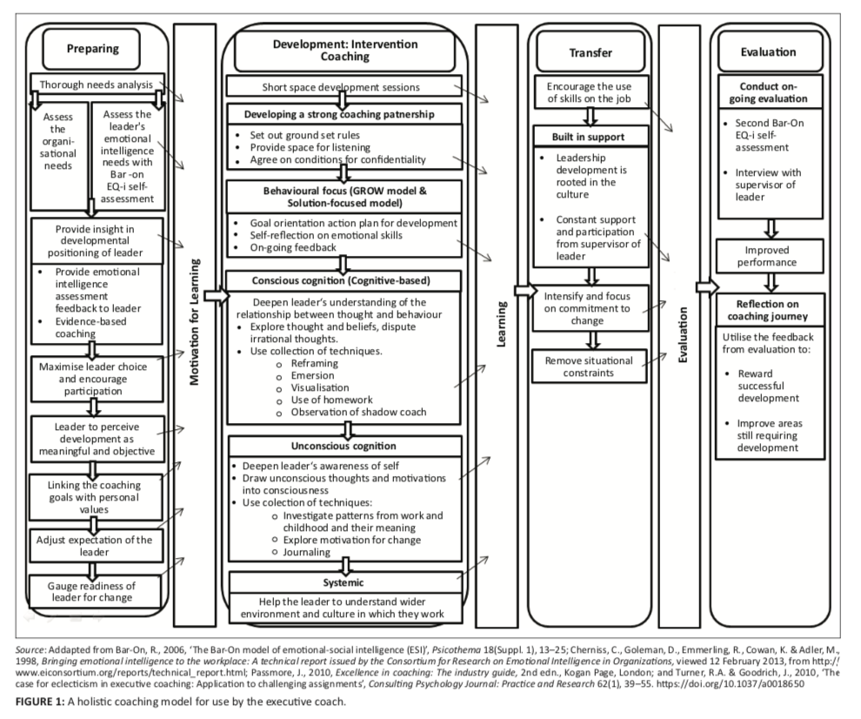

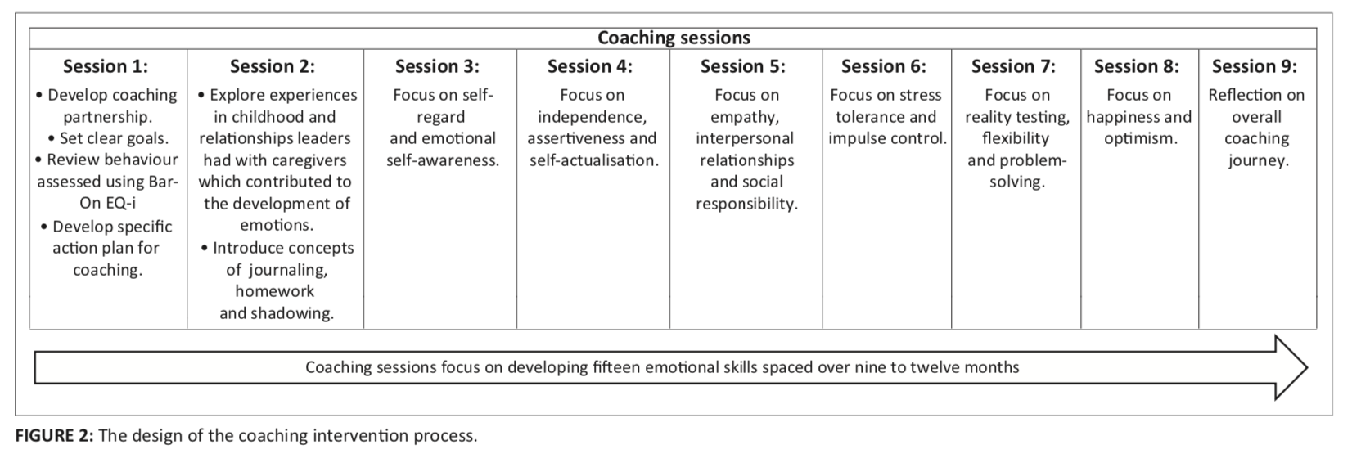

Dippenaar and Schaap Method Results.The results of their research indicated that coaching significantly impacted the emotional and social intelligences of the leaders in terms of their intrapersonal competency, interpersonal skills, stress management, self-regard, and empathy (2017). Their research provided conclusive empirical evidence of the positive impact of executive coaching when it is long-term, spaced out, and goal focused (2017). Although the results indicated coaching impacted the leaders positively, the downside to Dippenaar’s research study was the use of self-reporting questionnaires that increased the risk of the leaders responding to the study in a desirable way instead of constructive and valid. To sum of Dippenaar’s study, he states, “Despite the evidence obtained from research that suggests that executive coaching may be an effective leadership development strategy, insufficient research has been done that demonstrates the impact of theoretically substantiated and appropriately designed coaching interventions on the ESC’s of leaders” (2017, p. 13).

## Setting and Participants

The extended future research of Dippenaar’s study will take place in an office setting where other business is conducted. The business setting will allow the leaders to feel more comfortable in the business environment to be interviewed where it is familiar to them. Other participants in the extended study include coworkers of the leaders in which snowball sampling will be implemented to gain an understanding of what degree the leaders changed over the course of the year after coaching took place (Dandira, 2012; Pelletier, 2011). To grasp the terminology of “snowballing”, according to Pelletier, snowball sampling is appropriate where potentially disturbing information may come from respondents who have been harmed or a traumatic event could have occurred (Pelletier, 2011). A 360 degree survey (see Appendix A) will be dispersed via email anonymously to the participants. The snowball sample participants included by not limited to: peers, managers, upper management, colleagues, subordinates, and others which may include clients, contractors or vendors the leaders has current and previous contact with.

## Instrumentation of the Research Design

The instrumentation of the extended research design will utilize interviewing, two different personality tests, and 360 degree surveys to examine the impact of coaching on toxic leaders. The purpose of utilizing these instruments is to empirically examine the data to validate if the hypothesis of the study if correct: executive coaching can positively impact those who display toxic leadership traits.

Illustration 1 is a flowchart that provides a map of the instruments used throughout the methodology of the extended study. The leaders will be interviewed by behavioral specialists that will consist of ten questions regarding their experience with Dippenaar’s coaches and the effects it made to their occupational and personal life (see Appendix B). The personality tests in the study include: Change Indicator Style and Myers Briggs Type Indicator. As previously mentioned above, the 360 degree survey will be dispersed to all peers, managers, vendors, managers, and self-assessment. This extended study will solicit feedback from all participants approximately 12 months after Dippenaar’s coaching sessions to analyze if there was permanent change. The importance of this research design is to measure the level of change and impact of coaching on the leader.

The literature review indicated a gap that coaches can and cannot be rehabilitated through implementation of coaching or therapy methods (Goldman, 2014; Kets De Vries, 2014; Allio, 2013). Kets De Vries states, “While these disorders can be managed, some toxic leaders will prove impossible to change” (2014, p. 3). The research methodology used within this study may close the gap to understand if a toxic leader can be transformed into a functional leader.



## Procedure of the Study

The author of this study will be provided a full list of names and contact information of all leadership subjects that participated in Dippenaar’s research. The author will contact each subject by phone and email to inquire about furthering Dippenaar’s research study. The author will organize a meeting place for the subjects. Behavioral specialists should be involved to ensure all interview questions and surveys are protected and passed under the National University Institutional Review Board (IRB). The specialists will conduct the interviews and disperse the questionnaires to subjects who were willing to participate.

The leadership participants can provide the author with contacts to their human resources department in which they currently work for. The author will contact their HR representative to set up a time and day for the 360 surveys to be distributed to each snowball participant.

## Data Processing and Analysis

The study will utilize a process of data collection, analysis, and findings after all data is collected i.e. interviews, personality tests, and surveys. The data will be analyzed through utilization of various methods. The interview data collected will be empirically analyzed through listening and reading all interview transcripts, labeling relevant pieces of the subject answers, and placing a code on the relevant keywords (Creswell, 2014). An example of potential keywords is displayed in table 3.

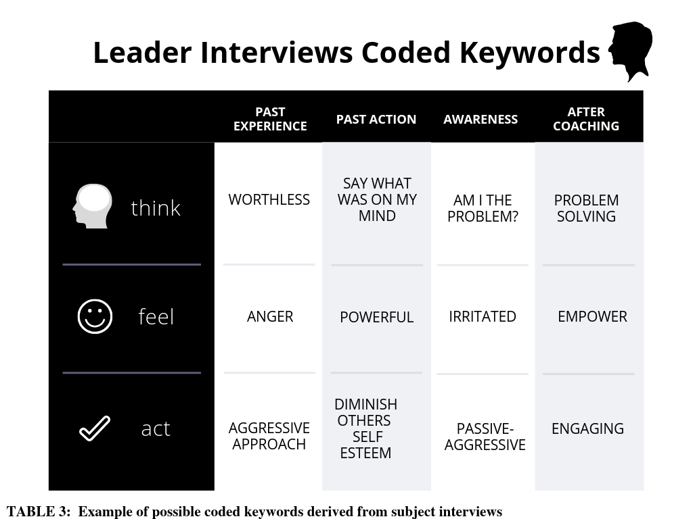

The transcripts will provide unbiased evidence of the keywords used that are coded then translated utilizing a quantitative method approach. The keywords and other data provided by the audio of the interviews and transcripts will be examined through the software of atlas.ti. The software atlas.ti is a tool that arranges, reassembles, and manages data that codes qualitative data and quantifies it in a meaningful way (n.d). The other data collected such as the personality tests (MBTI, CSI), and 360 degree survey will be analyzed using their preferred methodology.

### Personality Tests Scoring

The MBTI test scoring seeks out to assess if the participant is an introvert/extrovert, sensing/intuiting, thinking/feeling, judging/perceiving (Kennedy, and Kennedy, 2004). The CSI test will be distributed after the MBTI test and will be evaluated to measure if the leaders are an originator, conserver, pragmatist, or conserver (Musselwhite, and Ingram, 2000). According to Musselwhite, “Regardless of how we experience change or how we feel about it, change is here to stay. By understanding our change preferences and the preferences of others we can become better able to lead, manage, and assist others through the inevitable changes in our lives and organizations” (2000, p. 3).

## Ethical Considerations

This study involves human subjects in which all subjects, participation consent, methodology, interview protocol, surveys and emails will be reviewed and approved by National University Institutional Review Board (IRB). The IRB process allowed the researcher to study human subjects that pose minimal risk to those who participate in interviews or surveys. All participants and subjects gave the researcher consent for participation. The IRB approved this research with sufficient ethical research participation.

## Limitations to the Study

The limitations to this study may include the subjects sharing information that is in the interest to the researcher. The interview data could be swayed to positivity reflect change that did not occur. The other data analysis conducted will counter the interview data in which this would detect the leader’s deception to sway the accuracy of the study. This research study will not include leadership theory related to transforming toxicity. The boundaries chosen for this study include prohibiting follow up with abused subordinates or offering coaching, or counsel.

## Research Validity

This research study guards against response bias through the utilization of wave analysis. Creswell states, “In wave analysis, the researcher examines returns on select items week by week to determine if average responses change” (2014, p. 162). As part of the rigorous data collection process, all instruments used throughout this study will consider the following: indicate if the developer of the research instrument has the permission to use all parts, specify if other instruments will need to be used or obtained, if there are any changes that need to be made to the study that is not outlined within this paper, and to cross-validate all data collected to ensure accuracy (Creswell, 2014, p. 162).

# References

Bartlett, James E, and Bartlett, Michelle E (2011). Workplace Bullying: An Integrative Literature

Review. Advances in Developing Human Resources 13.1: 69-84.

Bell, R. M. (2017). The dysfunction junction: The impact of toxic leadership on follower

effectiveness. Available from ProQuest Dissertations & Theses Global. (1881834074).

Boddy, C. R., & Croft, R. (2016). Marketing in a time of toxic leadership. Qualitative Market

Research, 19(1), 44-64.

Burke, R. J. (2017). Toxic leaders: Exploring the dark side dagger. Effective Executive, 20(1),

10-14.

Burns, Jr.,W. A., Ph.D. (2017). A descriptive literature review of harmful leadership styles:

Definitions, commonalities, measurements, negative impacts, and ways to improve these

harmful leadership styles. Creighton Journal of Interdisciplinary Leadership, 3(1), 33-52.

Choudhary, A. I., Akhtar, S. A., & Zaheer, A. (2013). Impact of transformational and servant

leadership on organizational performance: A comparative analysis. Journal of Business

Ethics, 116(2), 433-440.

Chua, S. M. Y., & Murray, D. W. (2015). How toxic leaders are perceived: Gender and

information-processing. Leadership & Organization Development Journal, 36(3), 292-

307.

Cote, R. (2018). Dark side leaders: Are their intentions benign or toxic? Journal of Leadership,

Accountability and Ethics, 15(2), 42-65.

Creswell, J. W. (2014). Research design: Qualitative, quantitative, and mixed method

approaches. Los Angeles: Sage.

Dandira, M. (2012). Dysfunctional leadership: Organizational cancer. Business Strategy Series,

13(4), 187-192.

Dippenaar, M., & Schaap, P. (2017). The impact of coaching on the emotional and social

intelligence competencies of leaders. South African Journal of Economic and

Management Sciences, 20(1).

Farina, S. E. (2015). Leadership development coaching: Best practices for improving

performance in crafting vision, building alignment, and championing implementation.

Goldman, A. (2006). Personality disorders in leaders. Journal of Managerial Psychology, 21(5),

392-414.

Goldman, A. (2014). Transforming Toxic Leaders. Redwood City: Stanford University Press.

Hubbard, P. (2018). Assessing the effect and impact associated with toxic and ineffective

leadership. Available from ProQuest Dissertations & Theses Global. (2128012338).

Kets De Vries, M. F. R. (2014). Coaching the Toxic Leader. Harvard Business Review, 92(4),

100–109.

Kennedy, R. B., & Kennedy, D. A. (2004). Using the Myers Briggs type indicator® in career

counseling. Journal of Employment Counseling, 41(1), 38-44.

Lipman-Blumen, J. (2005). Toxic leadership: When grand illusions masquerade as noble visions.

Leader to Leader, 36, 29–36.

Lipman-Blumen, J. (2006). The allure of toxic leaders: Why we follow destructive bosses and

corrupt politicians—and how we can survive them. New York: Oxford University Press.

Lutgen-Sandvik, P. (2003). The communicative cycle of employee emotional abuse.

Management Communication Quarterly: McQ, 16(4), 471-501.

Mehta, S., & Maheshwari, G. C. (2013). Consequence of toxic leadership on employee job

satisfaction and organizational commitment. Journal of Contemporary Management

Research, 7(2), 1-23.

Mehta, S., & Maheshwari, G. C. (2014). Coaching the toxic leader. International Journal of

Management, 5(10), 18-24.

Musselwhite, W.C. and R. P. Ingram (2000). Change Style Indicator. Greensboro, NC:

Discovery Learning Press.

Pelletier, K. L. (2012). Perceptions of and reactions to leader toxicity: Do leader– follower

relationships and identification with victim matter? The Leadership Quarterly, 23(3),

412-424.

Pelletier, K. L. (2010). Leader toxicity: An empirical investigation of toxic behavior and rhetoric.

Romm, D. (2007). The Allure of Toxic Leaders: Why We Follow Destructive Bosses and

Corrupt Politicians – and How We Can Survive Them. International Sociology, 22(2),

263–263.

Swid, A., & Ragab, D. (2018). Narcissistic leaders: A review of astonishing success and

remarkable failure. Journal of Leadership, Accountability and Ethics, 15(3), 31-39.

Syaifuddin. (2016). The influence of work stress and transformational leadership on work

motivation and implication of employee's performance (case study). Academy of

Strategic Management Journal, 15, 42-48.

Taylor, G. (2013). Implementing and maintaining a knowledge sharing culture via knowledge

management teams: a shared leadership approach. Journal of Organizational Culture,

Communications and Conflict, 17(1), 69-91.

Thoroughgood, C. N., Sawyer, K. B., Padilla, A., & Lunsford, L. (2018). Destructive leadership:

A critique of leader-centric perspectives and toward a more holistic definition. Journal of

Business Ethics, 151(3), 627-649.

Thumma, S. A., & Beene, S. (2015). The judge as servant-leader. The Judges' Journal, 54(1), 9-

13.

Tsai, Y. (2011). Relationship between Organizational Culture, Leadership Behavior and Job

Satisfaction. US National Library of Medicine National Institutes of Health.

van Dierendonck, D., & Patterson, K. (2015). Compassionate love as a cornerstone of servant

leadership: An integration of previous theorizing and research. Journal of Business

Ethics, 128(1), 119-131.

Vredenburgh, D., & Brender, Y. (1998). The hierarchical abuse of power in work organizations.

Journal of Business Ethics, 17(12), 1337-1347.

Vreja1, L., Bălan2, S., & Bosca, L. (2016). An Evolutionary Perspective on Toxic Leadership.

Management and Economics Review, 1(2), 217-228.

Walton, M. (2011). Leadership behavior-in-context: An antidote to leadership hype. Industrial

and Commercial Training, 43(7), 415-421.

What is ATLAS.ti. (n.d.). Retrieved from https://atlasti.com/product/what-is-atlas-ti/

Whicker, M. L. (1996). Toxic Leaders: When Organizations Go Bad. New York:

Doubleday.

Yasir, M., & Mohamad, N. A. (2016). Ethics and morality: Comparing ethical leadership with

servant, authentic and transformational leadership styles. International Review of

Management and Marketing, 6(4).

Zagross, H., & Jamileh, Z. (2016). Relationship between Toxic Leadership and Job Stress of

Knowledge Workers. Studies in Business and Economics, 11(3), 84-89.

# Appendix A

360 Degree Survey Leadership Feedback

You are providing feedback to: [Participant Name Here]

You have been randomly selected to provide feedback for the name listed above. Your feedback is an important part of [Participant Name Here]'s leadership development and evolvement process. This tool is intended to gather broad feedback that are important for the on-going success of our organization.

In responding to the assessment form, please think about your experiences working with this individual during the last twelve months. Your responses will be merged with other's feedback and data will be collected for research purposes. This survey is anonymous and will not be shared with the participant.

Instructions:

You have been asked to evaluate yourself as part of a 360-degree feedback process. Please choose the best answer that describes the participants name above.

|  |  |  |  |  |  |
| --- | --- | --- | --- | --- | --- |
| Question | Needs improvement | Needs to develop | Satisfactory | Above average | Exceeding |
| Makes good decisions that benefit others | 🞎 | 🞎 | 🞎 | 🞎 | 🞎 |
| They can be counted on when needed | 🞎 | 🞎 | 🞎 | 🞎 | 🞎 |
| Takes ownership of mistakes | 🞎 | 🞎 | 🞎 | 🞎 | 🞎 |
| Is someone you can trust | 🞎 | 🞎 | 🞎 | 🞎 | 🞎 |
| Encourages employees | 🞎 | 🞎 | 🞎 | 🞎 | 🞎 |
| Is aware of problems and handles them well | 🞎 | 🞎 | 🞎 | 🞎 | 🞎 |
| Takes responsibility for results | 🞎 | 🞎 | 🞎 | 🞎 | 🞎 |

# Appendix B

Dippenaar Study Participants Interview Questionnaire (Extended Study)

|  |  |
| --- | --- |
| Question | Participant Answer |
| 1. Can you describe your coaching experience with your assigned executive coach? |  |
| 1. What were the greatest changes that you saw in yourself during your coaching sessions? |  |
| 1. Do you feel you had a problem with leadership? What about now? |  |
| 1. Can you describe any behaviors and actions that you exhibited at work that would cause someone to label you as “toxic” prior to your coaching experience? |  |
| 1. Please rate your coaching experience; 1 being the worst, and 10 the best. |  |
| 1. Can you describe yourself now of days? |  |
| 1. What positive changes did you experience after coaching? |  |
| 1. What behaviors do you still see in yourself that you’re currently working on? |  |
| 1. How would subordinates describe you now? |  |
| 1. How has your coaching affected your organization/company? |  |